The Scotstar Neonatal Transport Service is a national service and as such it may not always be the local team who move your baby, we all love to hear from the families we come into contact with, if you would like to let us know how your little
bundle gets on please do, or if you have any feedback for the teams please use our web contact form, email or message us, details below.

FACEBOOK – @ Scotstar Neonatal Transport
EMAIL -

Your baby...
Will be transferred to....
Your transfer team today is....
NEONATAL
TRANSPORT
SERVICE

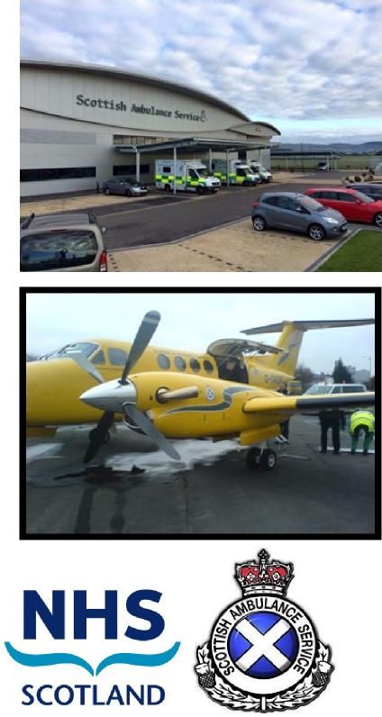

Dear family,
We know this is an extremely difficult and stressful time for you. This leaflet will help to answer some of the questions about your baby’s transfer. Please ask the team if you need any more information.
Why is my baby being transferred?
Babies are transferred for many reasons, but usually it's because they need more specialist care than their current unit can provide. This more specialist care is only available in a few units in Scotland. The doctors and nurses caring for your baby will tell you why your baby needs to be transferred to a different hospital
Who will transfer my baby?
The neonatal transport service exists to make sure the transfer is as safe and efficient as possible. We offer advice to your local hospital regarding your baby’s care, and we communicate with different specialist centers as your baby’s condition requires.
What happens when the transport teams arrive? The transport team will prepare your baby for the journey. This might mean giving them treatment such as sedation or pain relief so they are comfortable, calm and safe when we travel. Sometimes this takes time, but the team will update you regularly on your baby’s condition. The team is highly equipped with everything that might be necessary for the journey. We have our own specifically designed ambulance, but on occasion use other vehicles. If distance or time is a factor, we can also travel by plane or helicopter.
What will happen to my baby on the transfer?
Your baby will travel in an incubator similar to those used in neonatal units. This is to make sure that your baby is warm and comfortable throughout the journey, and it also allows the team to observe your baby at all times. The baby will also be attached to a monitor, which gives us information on their condition. If your baby needs help with breathing, or needs extra support with breathing when travelling, our vehicles are able to provide lots of different types of support, including a breathing machine (ventilator) if it is needed.
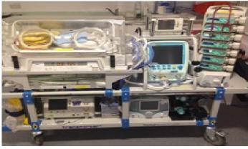 | Intensive  Care  Road Kit

Can I travel with my child?
In most instances we can invite one parent to travel with us, however there may be scenarios where it is deemed unsuitable for a parent to travel and in this instance careful and considered discussion should take place. If we are able to accommodate a parent then there will be certain criteria in place. Not all parents wish to travel in the ambulance and that is perfectly ok.
Mothers will not be allowed to travel in the ambulance unless they have been medically discharged from the post natal care team. If discharged the mother must also feel and appear to be fit and well and in minimum pain, be independently mobile and not known to be overly travel sick.
Self discharging or discharging against medical advice does not necessarily mean you are fit to travel with us and in this case we may ask that you make your own way to the receiving hospital. We are not a front line ambulance and if a mother was to become unwell we would have to request a 999 ambulance response to collect her as we cannot provide obstetric care. This will increase the length of time we have your baby in an ambulance and may be delay treatment to the detriment of the patient. Travelling in the ambulance requires you to travel backwards with a seat belt on at all times and this can be a bumpy journey. You must remain in your seat unless directed by the staff. Like on the neonatal unit, your baby will be attached to monitors, which may alarm. The staff will respond accordingly. Very rarely the ambulance may have to stop in order for the team to care for your baby, if this happens please follow the team's instructions.''
What will happen in the unit?
Generally, accommodation is available for you near your baby. The hospital your baby is travelling from will liaise with the receiving hospital to help accommodate this. The transport teams are unable to source accommodation at the babies receiving hospital for mothers and will not transfer the mum to the receiving post natal ward. If the mother is required to remain an inpatient the referring hospital will sort patient transport for her.
You will be encouraged to touch and talk to your baby as much as possible. However, you should always remember to wash your hands and dry them thoroughly before you do so.
Visiting rules vary depending on which unit you are transferred to. Generally, parents and siblings can be present on the unit at any time. Extended family and friends may have set visiting times. Only two people are allowed in at one time, to reduce the level of noise and congestion inside the unit.
In most units nursing staff change shift at 7am–8am and 7pm–8pm. Ward round times are daily, usually first thing in the morning.
In Summary
The neonatal teams are here to safely transfer your baby; if appropriate we will accommodate one parent to travel. If the teams are unable to offer this for any reason you must be prepared to make your own way to the receiving hospital, or await inpatient transfer.
If you have any questions about the transfer process, please do not hesitate to ask.
Resources
More information on the Neonatal Transport service can be found at
https://www.neonataltransport.scot.nhs.uk/
Bliss has a wealth of support and information
https://www.bliss.org.uk/parents/support
Young patients family fund information and claim form can be found below
https://www.mygov.scot/young-patients-family-fund

